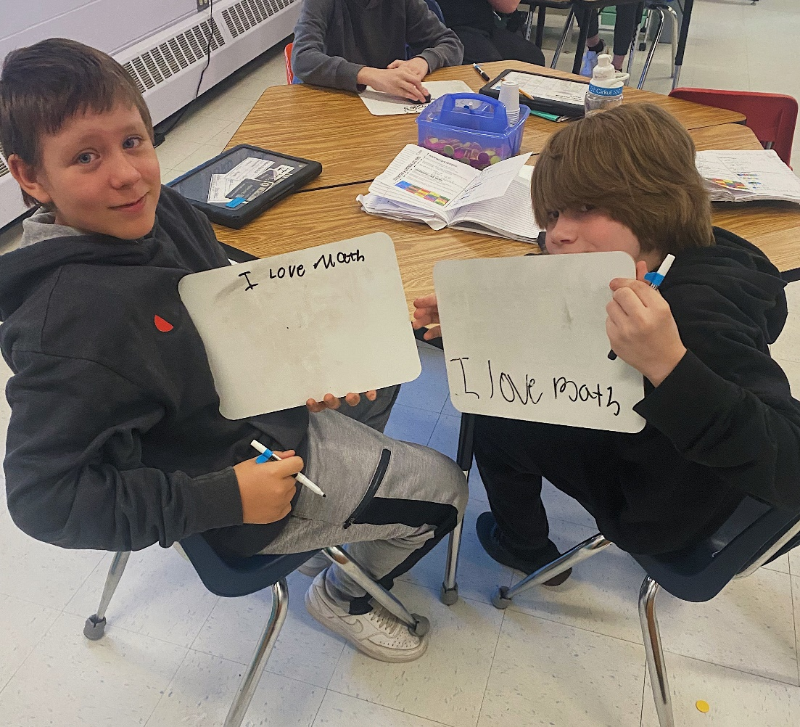
Seabrook Middle School Mission Statement:
It is the mission of the Seabrook Middle School to generate a passion for learning, and to provide a safe atmosphere which is conducive to educating, nurturing, and empowering all students to become responsible, productive, tolerant members of society.
February 18, 2024
Dear Parents and Guardians,
This week students are preparing for the ELA SAS which is scheduled for the week we return from vacation. Students will be practicing using the SAS writing modules during their RAM block. This exposure to the modulars will provide them an opportunity to practice prior to the test.
We have a few musical events planned for students this week, thanks to Mr. Woolley for scheduling these programs.
Our Grade 8 students continue to fundraise for their trip to Washington, D.C., we are half way to our goal. If you can help support them by attending the Grill 17 fundraiser on Wednesday, 2/21 from 4-7 p.m.
We have been fortunate to be able to go outside almost everyday and continue to remind students to dress appropriately, as it can get windy!
Be well,
Colleen
UA Schedule 2/19-2/23
DABCD

Clarinets after school Thursday

The Clemenzi Crusaders are presenting a music show for 7th and 5th graders during their UA Monday.

The WHS Jazz band and chamber singers are performing for the whole school on Tuesday.

Breakfast/Lunch 2/19-2/23

Grade 8 News
The World Language Department from WHS visited our school this past week. Students learned about the options they have next year for which language they can study.
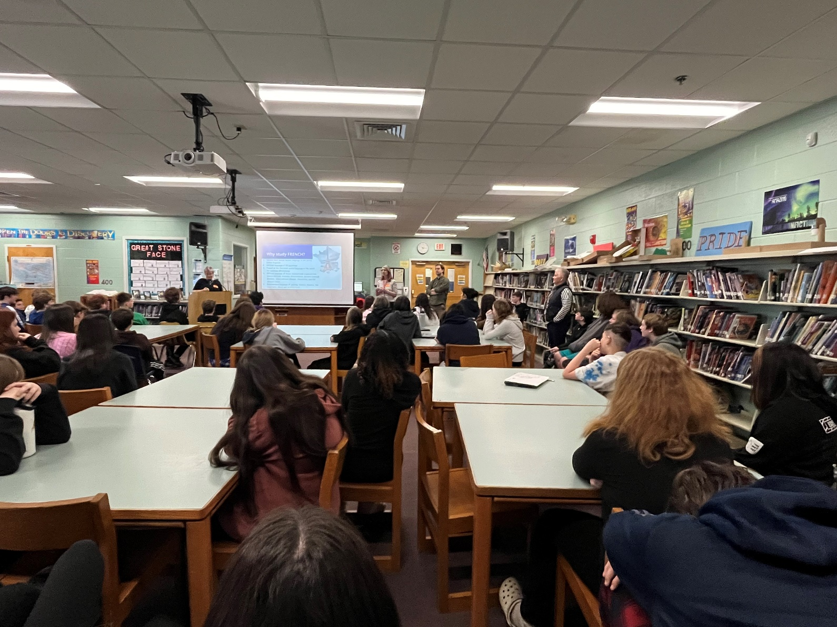
WHS Counselors visit SMS 2/22 to meet with Grade 8 students to help with course selection
NAEP Test 2/23
50 randomly chosen Grade 8 students will take the NAEP test on Friday, February 23, 2024.The test is administered nationwide to students in Grades 4&8.

Spirit Week 2/19-/2/23

Next week we will have a schoolwide Spirit Week, participation is voluntary.
Monday (2/19)-Sports Day-Wear your favorite sports team.
Tuesday (2/20)-Teacher-Student SWAP-students dress like a teacher…teachers dress like a middle schooler.
Wednesday (2/21)-Twin/Triplet Day-Find a friend or 2 to dress alike.
Thursday (2/22)-Class Color day-RAM ASSEMBLY
5th-pink
6th-black
7th-gray
8th-blue
Friday (2/23)-Hawaiian Day-Get ready for vacation with Hawaiian shirts, skirts, flip flops

Drop off procedures
We have had some challenges with the drop off procedures for our middle school students. Attached is a copy of the procedures put in place at the beginning of the school year. We appreciate your support so that everyone is safe when arriving and leaving school.

Power School Link
Some parents are having difficulty with Power School. Below is a link to use as a resource.
https://www.sau21.org/departments/resources/powerschool

The New Hampshire School Fair Funding Project (NHSFFP) presentation on School Funding and Property Taxes will be held on Tuesday, March 5, from 6-7 p.m.
WHERE:
Hampton Academy Cafeteria, 29 Academy Ave.
WHAT:
SAU 90, SAU 21, the Hampton School Board and NHSFFP invite community members to attend a presentation to learn more about how New Hampshire downshifts the cost of public education funding to property taxpayers, and how this system creates disparities in tax bills from town-to-town and in the quality of education students receive.
The presentation will cover the history of the decades long fight for equitable school funding, explain the current model and show local examples of the inequities it creates, and bring the issue to the present by discussing the recent NH Supreme Court rulings, the legislature, and the path forward.
This is an hour-long event that will include plenty of time for a Q&A portion.
By bringing together community members and elected officials, the districts and NHSFFP aim to emphasize the importance of fixing the school funding in New Hampshire and build momentum for change.
This presentation will be specific to SAU 90 and 21 and the specific problems these towns face in the School Funding Model. The presentation will be recorded and distributed to those who register.
Register Here.

Coming attractions:
February 26-March 1 Winter Break- School Vacation
March 3 -4-8 pm @Backyard Burger and Wings Restaurant Night Grade 8 fundraiser
March 4 -return to school
March 5&6- SAS Grades 5&6
March 7&8 -SAS Grades 7&8
March 7- EA Appreciation Day and Exhibition Night 5-6:30

